Inventory Management Tool

CS 157A Team 14

Khoa Phan

Jing Hui Ng

Renad Morrar

1. **Overview:**

Many businesses are having a problem to manage their inventory in an effective way. Our tool is to provide a friendly and useful tool in order to help those businesses be able to manage their inventory more effectively . In detail, the software will help companies to manage the stock of products with various functions such as generating reports, maintaining the balance of the inventory. Moreover, it will provide accurate information about the products without any error. In a general sense, the inventory system will work by allowing the user to manage and keep track of the stock. The most important goal that we are aiming for is providing a customer a better way to manage their business’s inventory more effectively, which will lead to save a lot of money and time for the companies.

**2**. **System Environment:**

**A. A Structure Diagram of the System:**

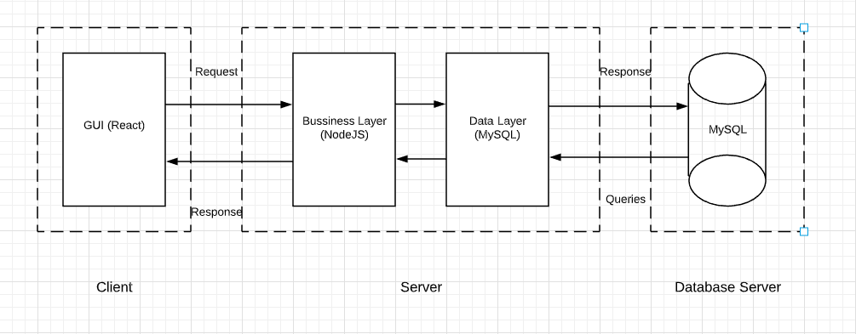

**B. Hardware & Software:**

* Back-end: **Node.js version: 10.16.3** (Javascript runtime environment), **Express.js** v4.16.1(Web application framework for node.js), **npm v6.9.0**
* Front-end: **React v3.0.1** (Javascript library for building UI), **Redux v4.0.4, Material UI v4.4.3**
* Database: **MySQL Workbench v8.0 CE**
* Misc: Any type of web browser (Chrome/Firefox/etc), Linux or Windows environment, and Wifi connect capability
* Visual Studio Code/Atom
* Git & Github
* Slack

**C. Programming/Application languages used:**

* Front-end: CSS, Javascript
* Back-end: Javascript

**3. Functional Requirements:**

1. **Functionality/Features:**

 User can decrease the quantity of the item or remove it from the stock. They also can see a graph showing the status of a particular item (increase or decrease in terms of quantity) at a specific time. The user can edit the price of a specific item. The search function will be implemented to help the user find the item by type of the product. The users also need to log in with a given account in order to have access to the management system.

1. **User Usage:**
2. Scenario: User login
   1. Access to the login page

* When users open the webpage they will have access to the log in screen, which will be displayed on the corner of the webpage.
* Log in screen will have the ID and password boxes provided
  1. Fill in the id and password (Account will be given in this case)
* Users will have an ID and password, they will be able to enter the text within a box and will be able to have access to there account after logging in successfully.
  1. Navigate to the homepage with account logged in
* With the account logged in, the user will be able to navigate directly to the homepage by clicking the special homepage button located on the webpage

1. Scenario: Searching item
   * 1. Write the type of item that the user wants to find in the search bar

* Search bar is provided for the user on the top screen of the webpage
* User will be able to enter text through the search bar and be able to find the item they entered within the search box
  + 1. A list of items will be displayed based on the type of items.
* After hitting the enter button to locate the item the user entered, there will be a list of items related to the users search

1. Scenario: Add and Decrease Quantity of Items
   * + 1. Search for the item that user wants to add more quantity.

* In order to add more quantity of the item, user should search for the item again and locate the exact item they wish to add more quantity of
  + - 1. Edit the quantity
      * User will be able to add or subtract how much of the item they wish to obtain by using the “+” or “-“ buttons provided next to the item

3. Click the Update Button

* A button with the sign “update” will be located at the bottom of the page in order to update the quantity the user has of the items

1. Scenario: Remove Item
   1. Search for the item that needs to be removed

* In the users inventory list, search for the item they wish to remove
  1. Click the remove button
* Locate the item, and next to the item on the side their will be a “remove” button
  1. Click the update button
* A button with the sign “update” will be located at the bottom of the page in order to update the removed item

1. Scenario: View Report
2. Search for the item

* User should first search and locate the item they wish to view

1. Click view report button

* For that item, there will be a “View Report” button located near the item

1. A graph will be displayed

* A statistical graph of the report will be displayed after clicking the button

**4. Non-functional Issues:**

1. **GUI:**

* It should be a Web Application with an user-friendly environment that will be built by using React & Material UI, CSS
* When the user first logged in, the user will be able to navigate directly to the homepage by clicking the special homepage button which will contain a list of items in the inventory.
* On the dashboard, the user will also see a simple search box with a magnifying-glass button that is displayed on the top middle. Also, search box will be provided on every page to ensure that the user is able to find the content they are looking for.
* Auto-suggest mechanism is provided when the user is typing in the search box by predicting what the user trying to look for to speed up the searching process.
* When the user selects on one item, it will show a detailed information of the item selected.
* User is able to edit the quantities of the selected item by changing the number and then simply clicking the update button.
* They should be able to see the pie charts and graphs when the click on the view report button on the web page in order to make stock control and inventory visibly easy, and allow the user to quickly see new trends, and help user to easily visualize the flow of the items.

1. **Security:**

* The system will be protected by a username and password.
* The username for each account will be the user’s corporate-based email to keep unauthorized users from accessing the system.
* The password should have at least 8 characters with on special character.
* In order to log into the system, an existing email account along with the associated password must be provided.
* There will be an inactivity timeout that will prompt the user to login again if the user is inactive for a certain amount of time.

1. **Access Control:**

* Only authorized users whom are employees from the company will be able to access the data and information in the system.
* Different user account will have different levels of permission.
* Access permission or level of permissions may only be modified by the admins account.
* Admin account will have total read and write access.